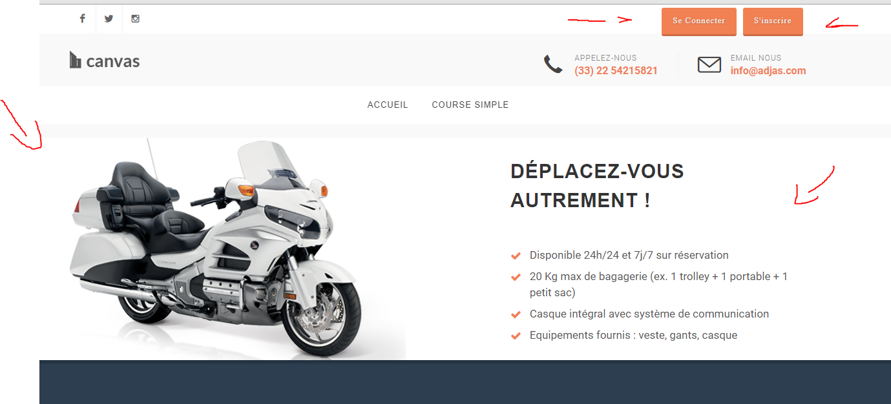

* 2017 Honda Gold Wing 1800
* The condition of the vehicle
* Login / Signup
* Drivers Button -> pop up new tab to a link

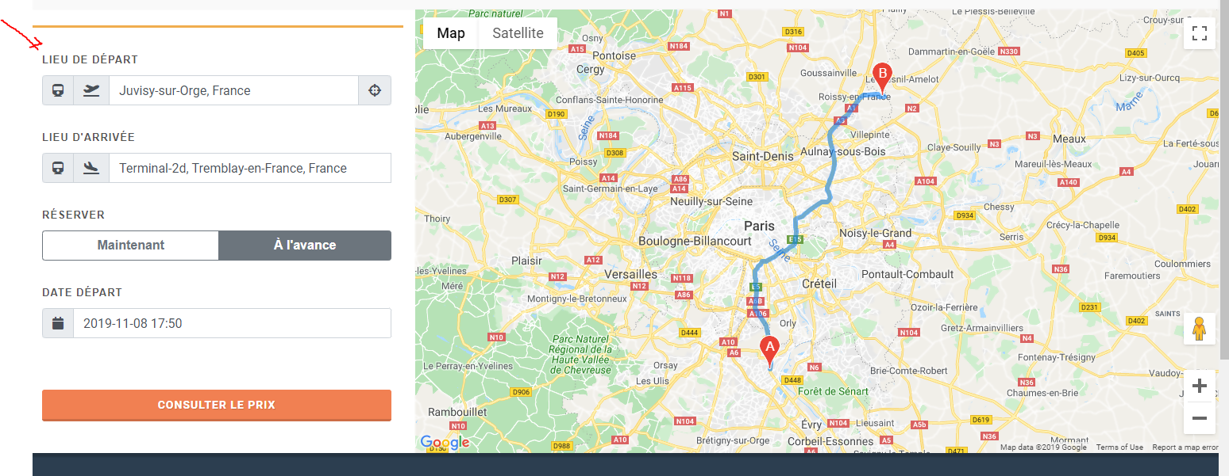

* Train stops, Airplane Stops, Custom Address
* Shows distance between the points
* Immediately | Reserve
* For Reserve (Date and Time )